

BSc Product Design Module DP607
Participant Consent Form

Title of Project: AI AND YOU
This research is investigating how the interface of AI Art and Design tools such as Stable Diffusion can be simplified and given a physical element for non-programmers without limiting the creative output.

Name of Researcher: JOE MILTON

 |  | Please initial or tick box
I have read and understood the information sheet for the above study, and have had the opportunity to consider the information and ask questions. |  | ✓
The researcher has explained to my satisfaction the purpose, principles and procedures of the study and any possible risks involved. |  | ✓
I am aware that I may be asked to take part in an interview |  | ✓
I understand that my participation is voluntary and that I am free to withdraw from the study at any time without giving a reason and without incurring consequences from doing so. |  | ✓
I understand that my participation may be video, or audio recorded |  | ✓
I understand how the data collected will be used, and that any confidential information will normally be seen only by the researchers and will not be revealed to anyone else. |  | ✓
I agree to take part in the above study. |  | ✓

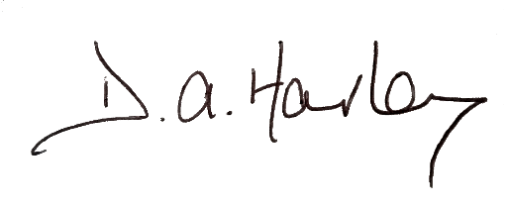

………………………………………………………………………………………………………………………………………
Name of Participant, Date, Signature


Joe Milton, 04/04/2023, ……………………………………………………………………………………………………………………………………….
Name of Researcher, Date, Signature

